Student’s Name
Instructor’s Name
Course Details
Date
Motherboard in Computer Technology
Another term for the motherboard is a system board, mainboard, or logic board. It serves a critical role in ensuring that all components of the computer receive power and also provides that they can all communicate with each other. To achieve the above function, the circuit board either houses or need a connection to all the parts that operate in the specific computer. The choice of motherboard requires keen consideration of configurations and features available. The motherboard's decision has to be compatible with the CPU of the system and should incorporate adequate memory slots and compatible extension. An additional element to keep in mind is future upgrading requirements. Typically, a motherboard is connected to the following components; processor interface, memory modules, expansion slots, backplane, onboard components, co-processors, cabinet connectors, faceplate connectors, onboard internal connectors, BIOS chip, CMOS battery, chipset, SATA connectors, and jumpers (Westerfield, Mitrovic and Billinghurst 160). Other boards come along with documentation, which holds all the relevant information inclusive of a diagram. The backplane describes a circuit board equipped with expansion slots, where a CPU may be inserted. The design is proprietary, and the component can either fit into either passive or active classifications.
The front side of the motherboard commonly has a chip, socket, capacitor, resistors, and an expansion slot. The interconnection of various parts within the logic board is accomplished through a bus, which also identifies the purpose of such connections. One such relationship is the local bus with a direct link to the CPU. Its function is the provision and enabling of communication at high speeds to all devices closely mounted to the CPU. There is also the I/O bus, which connects all the expansion slots to the CPU. CPU connects to the memory through the memory bus. The motherboard also has the power bus, data bus, internal bus, control bus, and the address bus.
The original design and architecture of the motherboard align with the XT form factor. The structure was such that only a single bus connected to all the components, inclusive of the TAM. The design also ensured matching speeds for both the CPU and the single bus. It is possible to identify motherboards based on their form factor, which is a term describing its outline or physical shape. The term for the old model is XT, which stands for eXtended Technology. The XT represents the first standardized model, developed for the IBM personal computer in 1983. The supply of power utilized the P8 and P9 connectors, used a DIN for keyboard connection, and had an 8-bit data bus. The mouse used a serial port. The AT (advanced Technology) motherboards are slightly larger than their XT counterparts. The model utilizes a serial port for the mouse, uses a DIN keyboard connector, and has a 16-bit data bus.
The model was superseded by the Baby AT, which also uses a 16-bit data bus and is smaller from advanced chip technology. The next model to follow was the ATX (advanced technology extended) motherboard in 1996, available in three standard sizes. ATX also had a 16-bit data bus. The BTX (balanced technology extended) had better cooling systems and acoustics than its predecessors through a reduction in heat and power needs (Hennessy & Patterson, 2011). BTX came in four standard sizes. LPX (low profile extended) motherboard is an earlier version designed for low-profile desktop computers. It had a proprietary design that did not allow for expansion slots but instead had a single slot for a bus riser card. The last model is NLX, which is similar to LPX, except for the design that allowed the bus riser card connection at the side (Ortmeyer 23). It is now considered as a standard. The proposal for the form factor was by Intel, but its development included joint efforts from IBM, DEC, and other vendors.
Models of motherboards that came much later utilized different speeds for the CPU and the bus speeds. The communication of varying bus speeds was possible through the chipset. A chipset describes a collection of electronic components within an integrated circuit useful for the management of data flow between the memory, processor, and the peripherals. The chipset exists in two; North Bridge and south bridge. The former controls PCI, L2, DIMM, and CPU slots, while the latter controls Super I/O IDE1, IDE0, serial port, printer, mouse, ISA slots, and USB. BIOS is the read-only memory module that enables the communication between the operating system and devices (Hussain 32). It also carries out boot sequence, CMOS setup program, and POST. The CMOS setup program either enables the built-in devices and ports. Additionally, it sets up power management and identifies system hardware. The storage of data from CMOS is on a volatile memory location chipset, and it does need battery power not to lose the data.
Expansion slots and cards allow for easy and fast means of connection for devices directly to the motherboard, allowing for customization and modification (Hennessy & Patterson 31). There are various types of expansion cards, each with different features and their progression marked through the eras. System resources include the PnP, bus mastering, direct memory access, I/O port address, memory address, and interrupt request. The last resource gains the attention of the CPU. I/O ports are used in the locating of devices by the COU. Memory address serves as a temporary storage area for data before the transfer, and its range is assigned as a section of memory. Bus mastering proves useful in allowing direct transfer of data between two devices (Bittner, 2012). Typical motherboards include two DMA controllers, with each including four channels. DMA allows for direct transfer of data to memory if it does not need the CPU's attention.
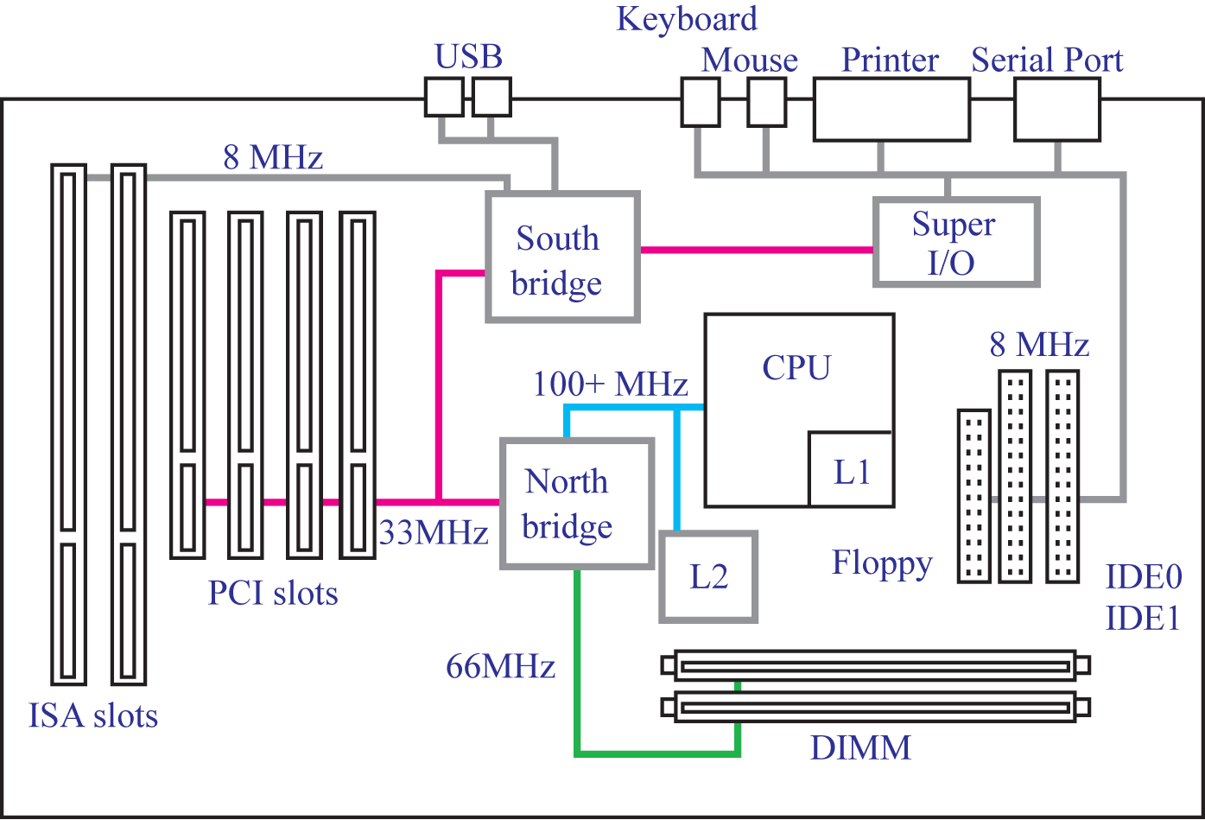

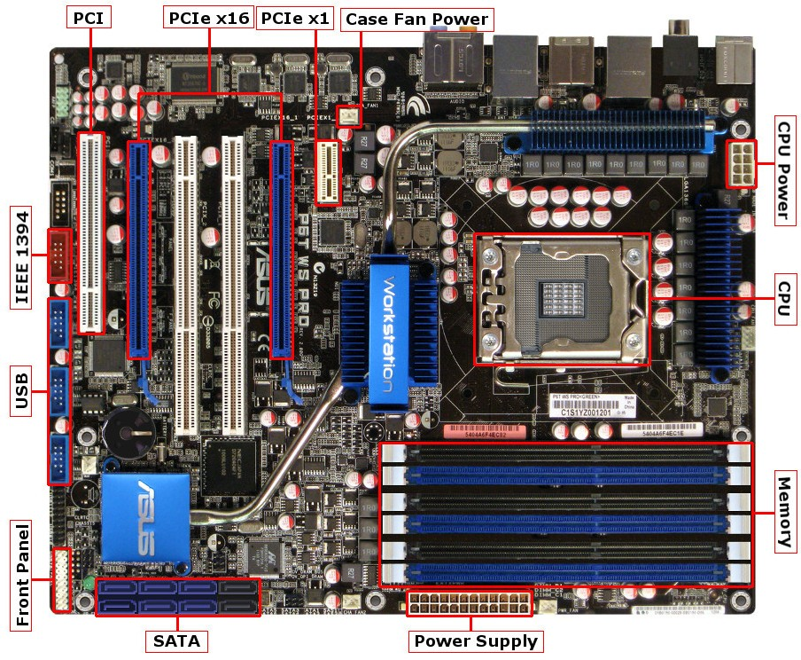
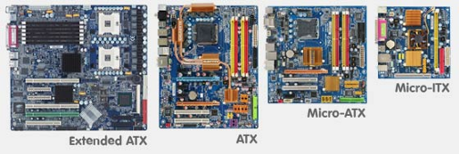

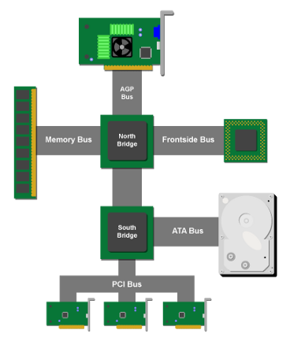

Work cited
Bittner, Ray. "Speedy bus-mastering PCI express." 22nd International Conference on Field Programmable Logic and Applications (FPL). IEEE, 2012: 12-45
Hennessy, John L., and David A. Patterson. Computer architecture: a quantitative approach. Elsevier, 2011. 8-45
Hussain, Baseer. System Hardware Component, Motherboard. 3 March 2017, accessed 6 June, 2020. https://medium.com/computing-technology-with-it-fundamentals/system-hardware-component-motherboard-8e3d44e29f74 9-54
Ortmeyer, Cliff. "A Brief History of Single Board Computers." A Premier Farnell Company, Electronic Design Uncovered, USA 06 (2014): 11. 10-56
Westerfield, Giles, Antonija Mitrovic, and Mark Billinghurst. "Intelligent augmented reality training for motherboard assembly." International Journal of Artificial Intelligence in Education 25.1 (2015): 157-172.

